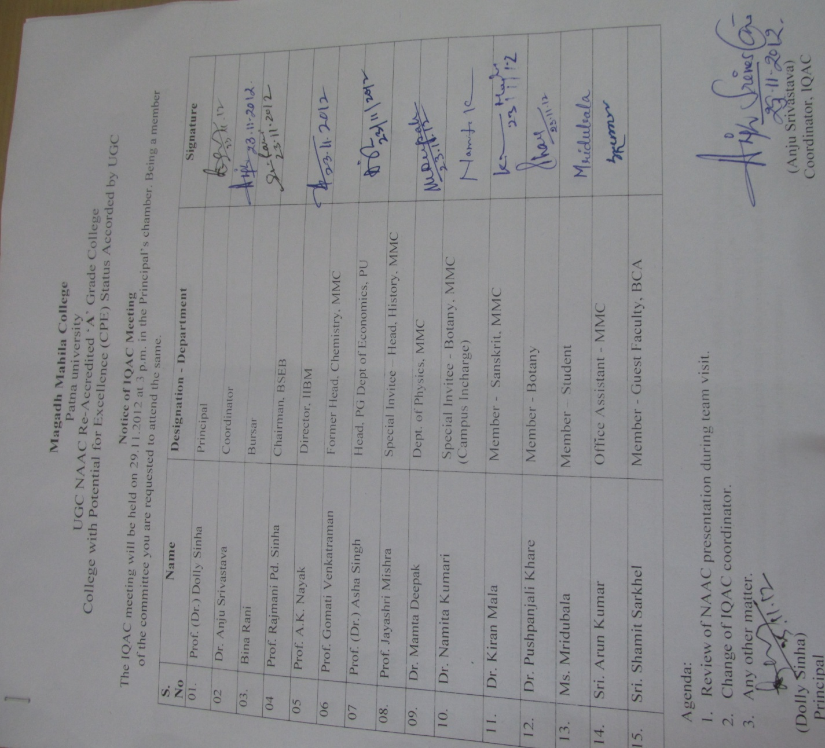
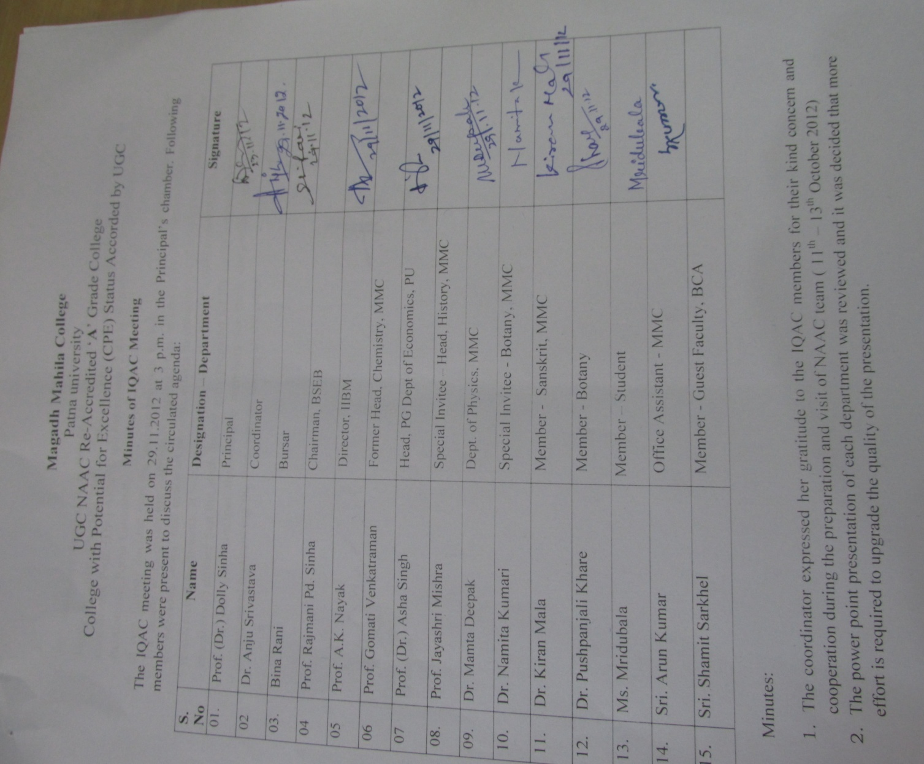

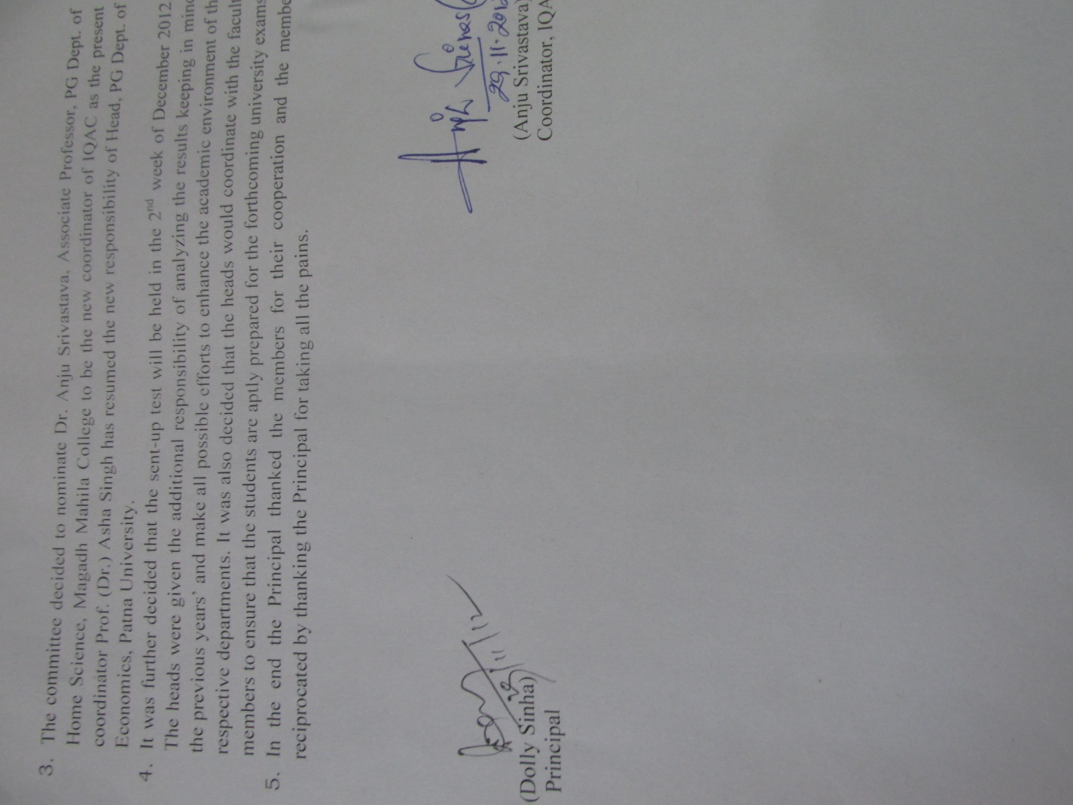
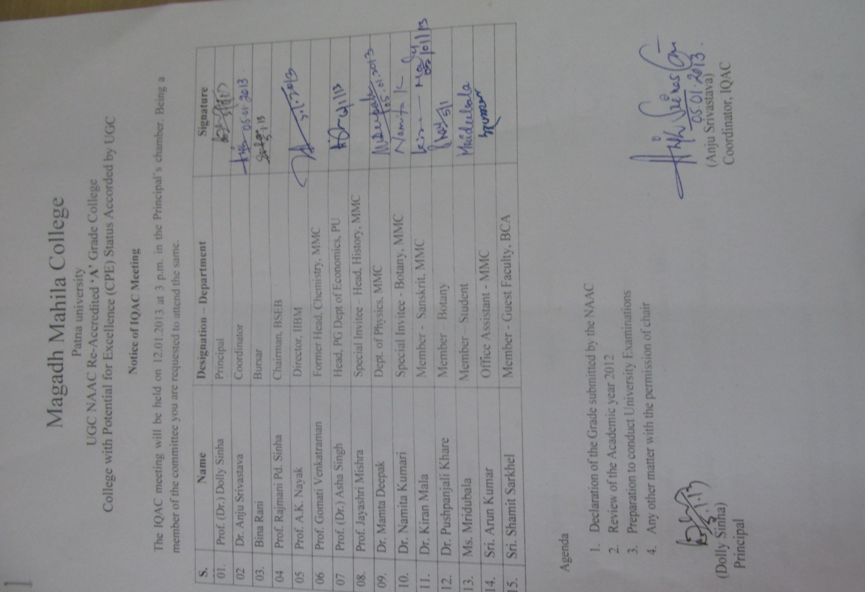

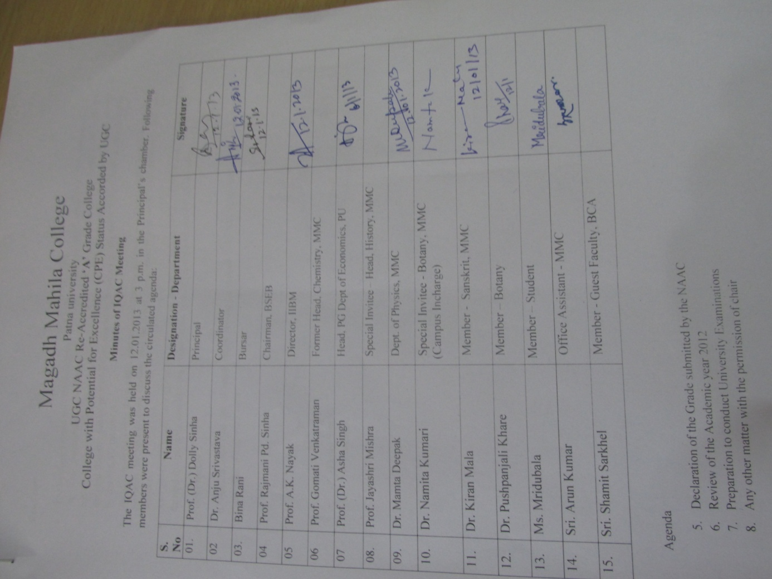
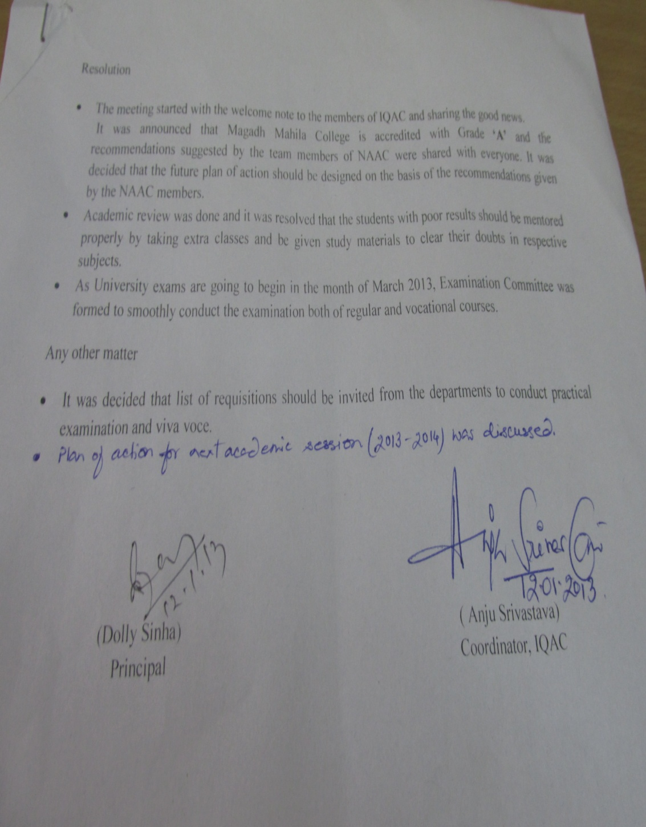

Action Taken 2012-13
- On the basis of the recommendations given by the NAAC Committee, action plans were formulated to add quality to the teaching learning process: ICT method of teaching, students’ seminar through PPT presentation, introduction of CPE research programme to undergraduate and postgraduate students to make education more comprehensive for the all around development of the students. Extension activities were carried out by NSS on social and environmental issues.
- Sent-up examinations were held in December 2012. The assessment of the results was done in the meeting with Heads of various Departments and Co-ordinator of Self-financing courses to review academic performance of the students. Students with poor results were given extra classes and study materials.
- College Examination Committee was formed in order to furnish proper and smooth conduct of University Examination 2013.
- The Departments submitted their requirements in light of the university practical examination and viva-voce 2013, for which necessary allotments were made to the respective U.G., P.G. and vocational programmes.

