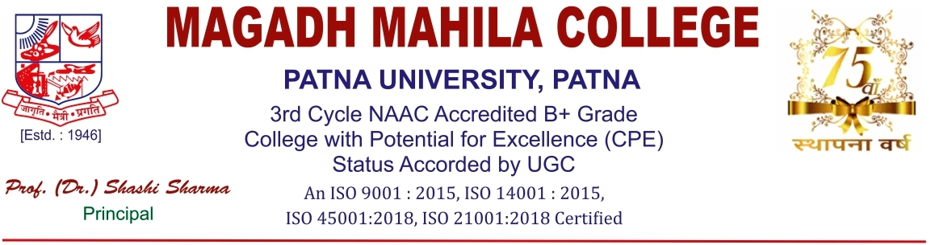

**Ref. No....................... Date: - 20.03.2021**

**NOTICE**

This is to inform you all that Students' Cabinet Election 2021 is going to be held on 1st of April 2021. The detail schedule to organize election is as follows:

**23.3.21**

Counselling will be held at Conference Hall from 12.30 pm to 1.30 pm.. Students who are interested to file the candidature should come with their result, attendance  and conduct certificate from their respective department for counselling.

**24.3.21**

Qualified Candidates will file their nomination on 24.3.21 from 12.30pm to 3.30 pm.

**25.3.21-26.3.21**

Campaigning will be done on 25th and 26th March 2021 during college hours from 12.30 pm to 4.30 pm

**01.4.21**

Voting will be held on 1st of April 2021 through MIS system. Result will be declared same day

**05.4.21**

Oath taking ceremony will be held on 5.4.21 at central stage at 12.30 pm. Classes will remain suspended from 12.30pm onwards.

**C:\Users\User\Desktop\Ram Kumar\singnature-1.jpg**

**20.03.2021**

Principal

Magadh Mahila College

