NAAC PEER TEAM EXIT MEETING REPORT
19th March 2019
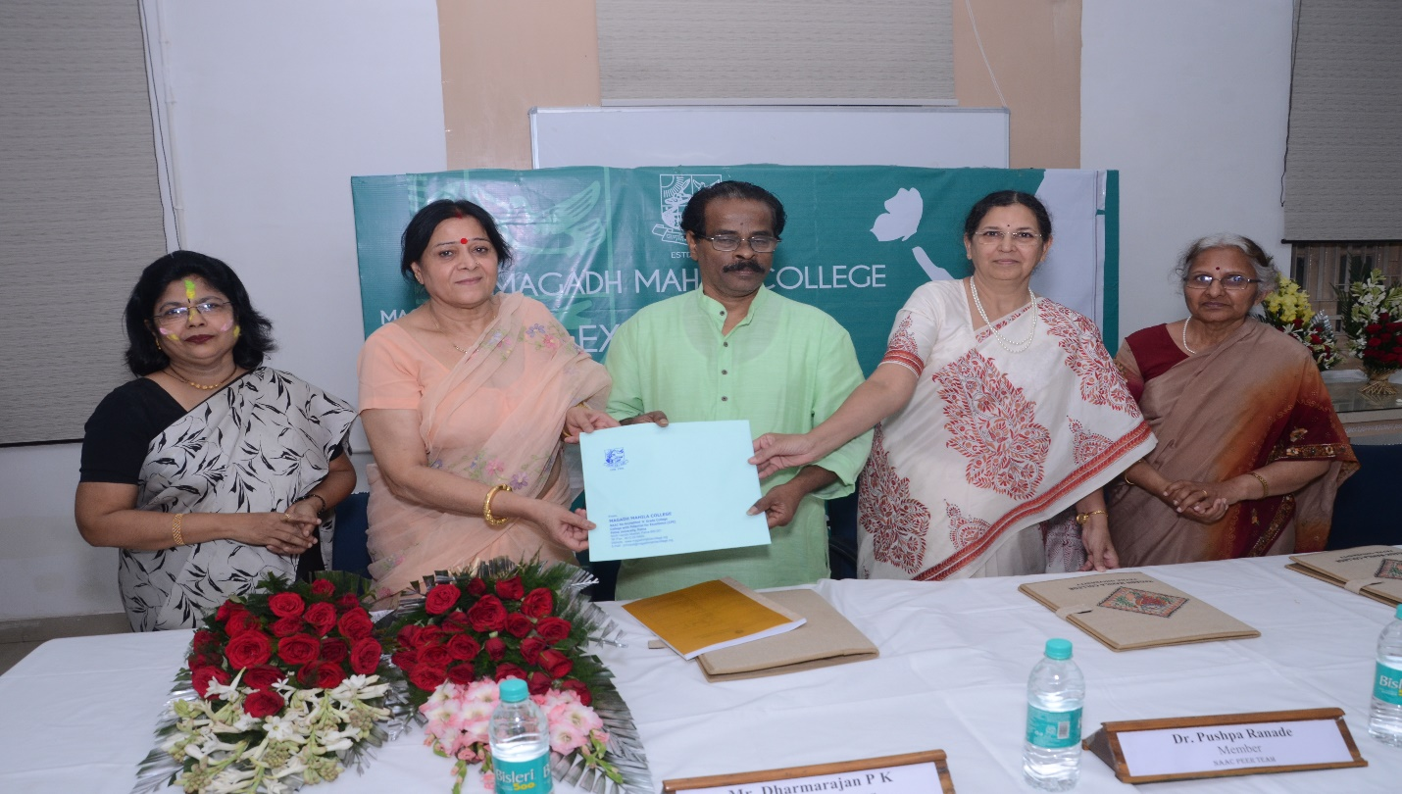
The Peer Team for NAAC Accreditation visited Magadh Mahila College, Patna University, Patna on 18th and 19th March, 2019 for the 3rd Cycle of Assessment and Accreditation.
The PEER TEAM comprising of Mr. Dharmarajan P. K., Samskrithi,Kalady, Ernakulum, Kerala as Chairperson , Dr. Madhu Raka, Department of Mathematics, Chandigarh as the member Coordinator and Dr. Pushpa Ranade, Pratham Patwardhan Baug,Pune as the member Peer Team visited various Departments, Laboratories and physical facilities provided in the campus. They interacted with the Principal, Prof (Dr.) Shashi Sharma, Prof Anju Srivastava, IQAC Coordinator, Heads of all Departments, Administrative staff, Students, Almumni and Parents.
Exit meeting of the Peer Team was held on the final day i.e on 19th March 2019. The Chairperson of the PEER TEAM , Mr. Dharmarajan P K shared the Peer Team views in the meeting and handed over the detailed Report to the Principal Prof (Dr.) Shashi Sharma.
All the teaching and Non-teaching staff members were present on this occasion. Principal Prof (Dr.) Shashi Sharma welcomed the gathering. Dr Anju Srivastava ,Co-ordinator IQAC extended vote of thanks. Dr. Md, Ziaul Hassan, Head of the Department of Philosophy anchored the session.
Prof (Dr.) Shashi Sharma, Principal of the College thanked the PEER TEAM for visiting the college for 3rd cycle accreditation and promised them that the College would continue with the activities that promote the interest of all students and follow the recommendations made by the PEER TEAM to enhance the quality of education and overall personality development of the students.
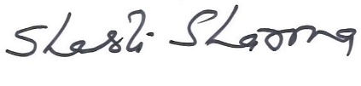
Prof. (Dr.) Shashi Sharma
Principal
Magadh Mahila College, Patna University

