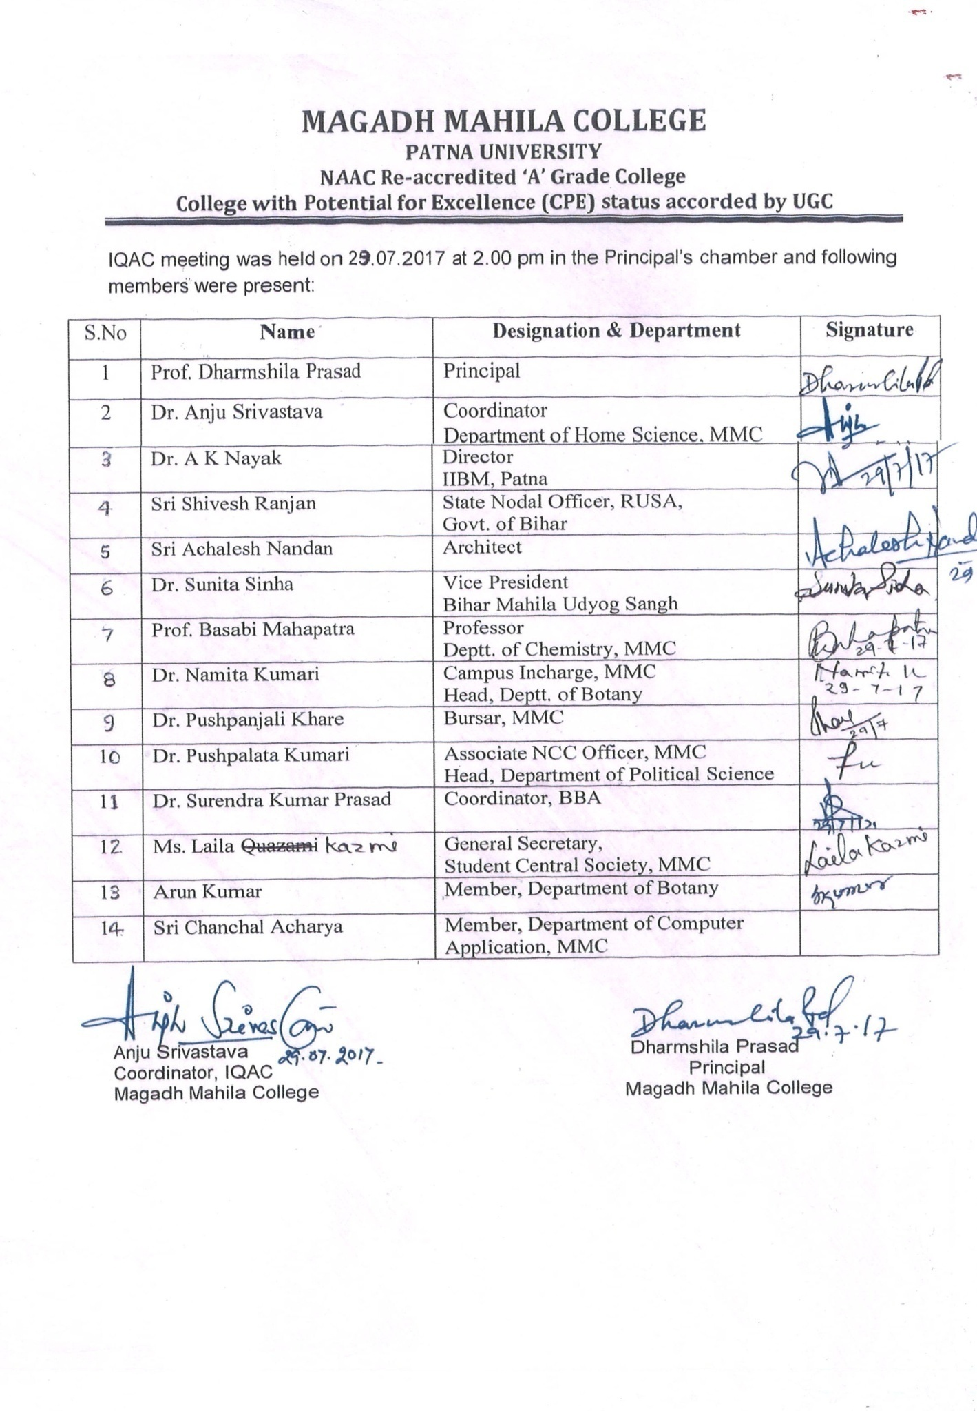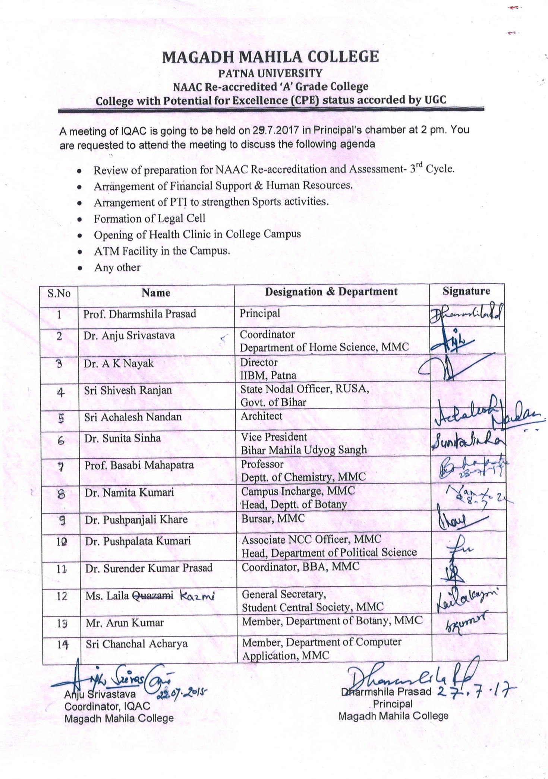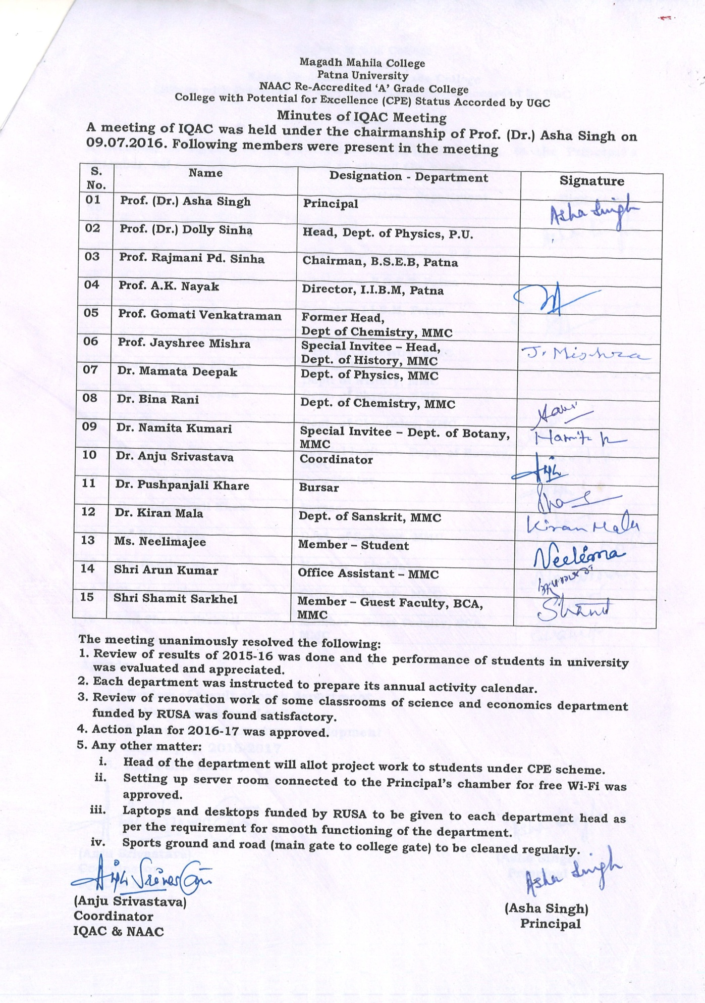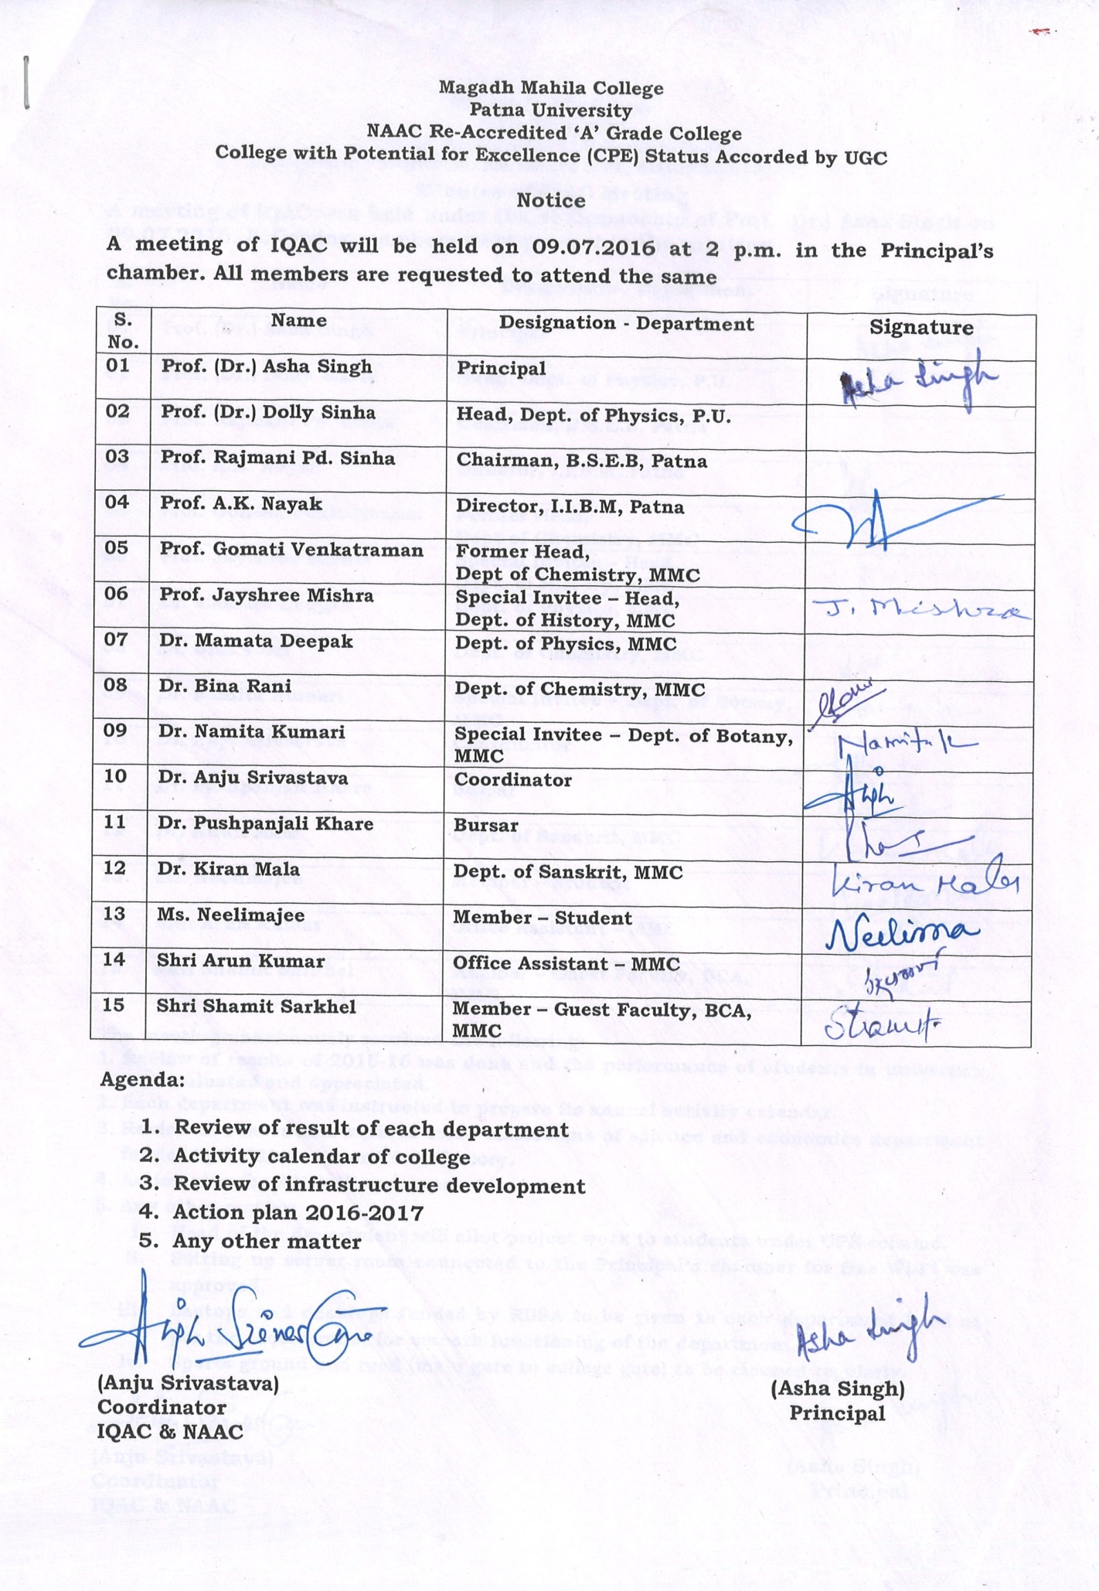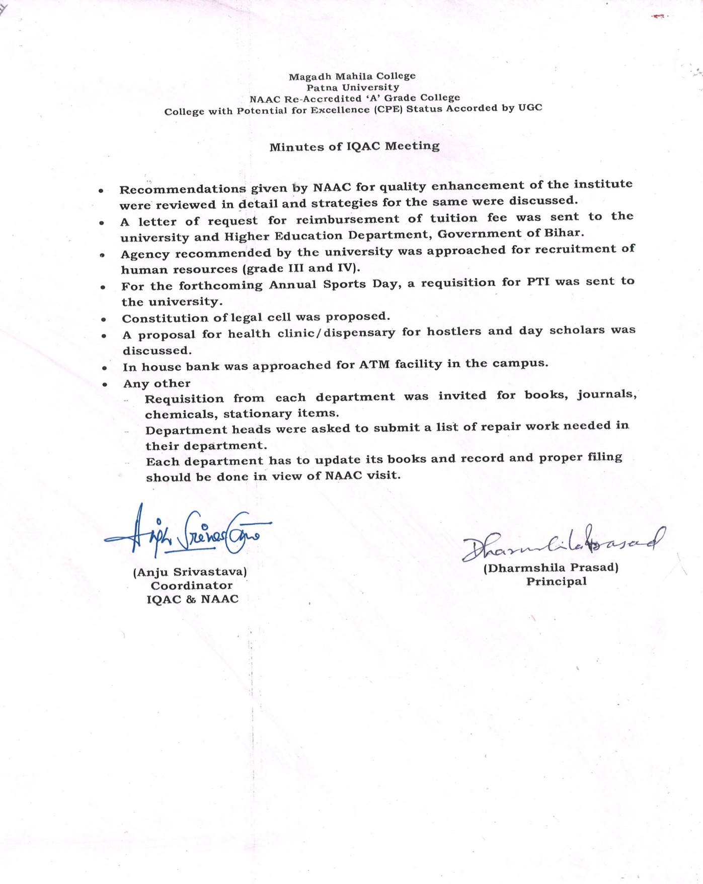

Action Taken 2016-17

- Ad-hoc teachers were appointed against vacant sanctioned post in every department. Retired teachers also engaged the classes. Non-teaching staffs were appointed against vacant sanctioned post in the college from out-sourcing.
- Proposal was sent to the government for the release of funds to solve the problems of financial crunch in the college.
- Faculty members of each department analyse the university result and future course of action in General Body Meeting.
- The departments prepared the academic calendar for the current academic session.
- Renovation of college office and false roofing of central stage was done.
- Legal Cell was constituted.
- Annual requisition from each department was submitted for books, journals, chemicals and stationary items.

