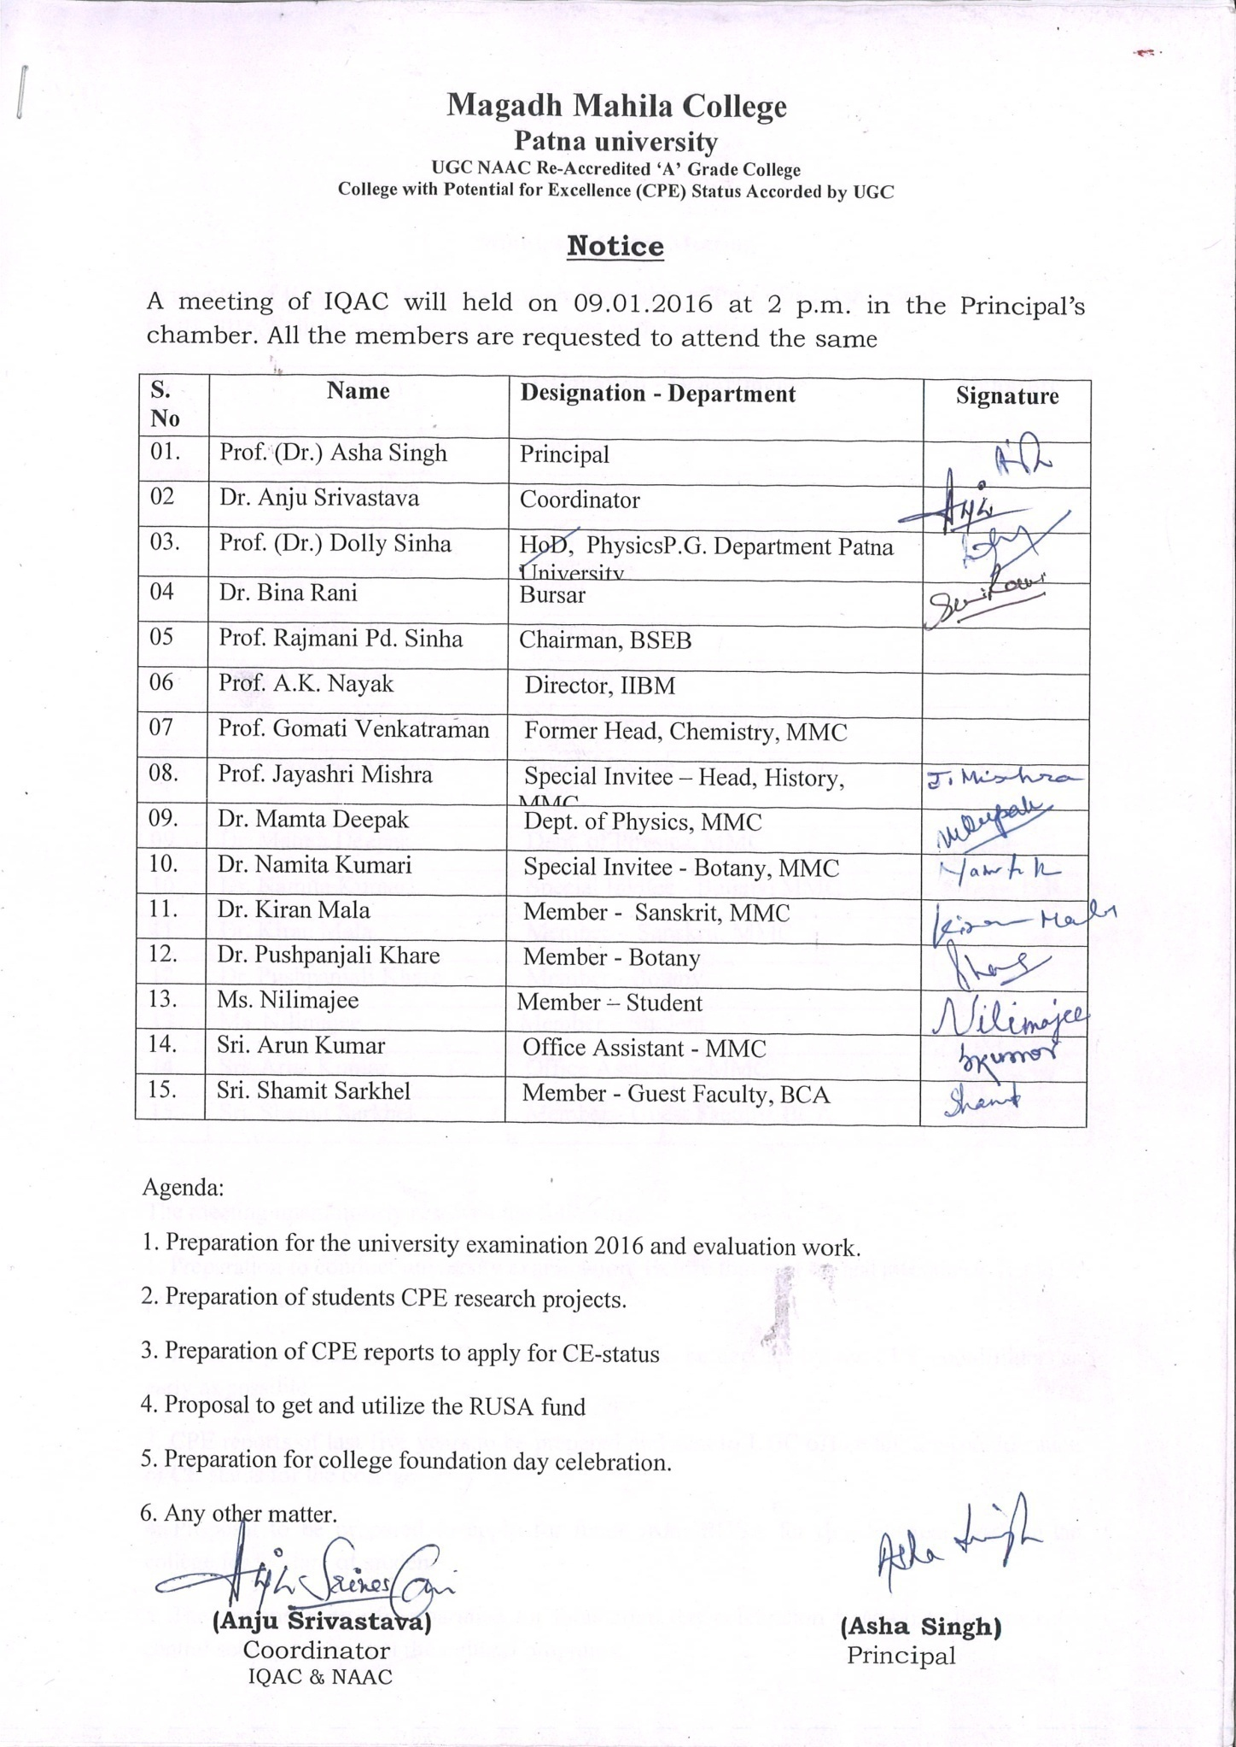

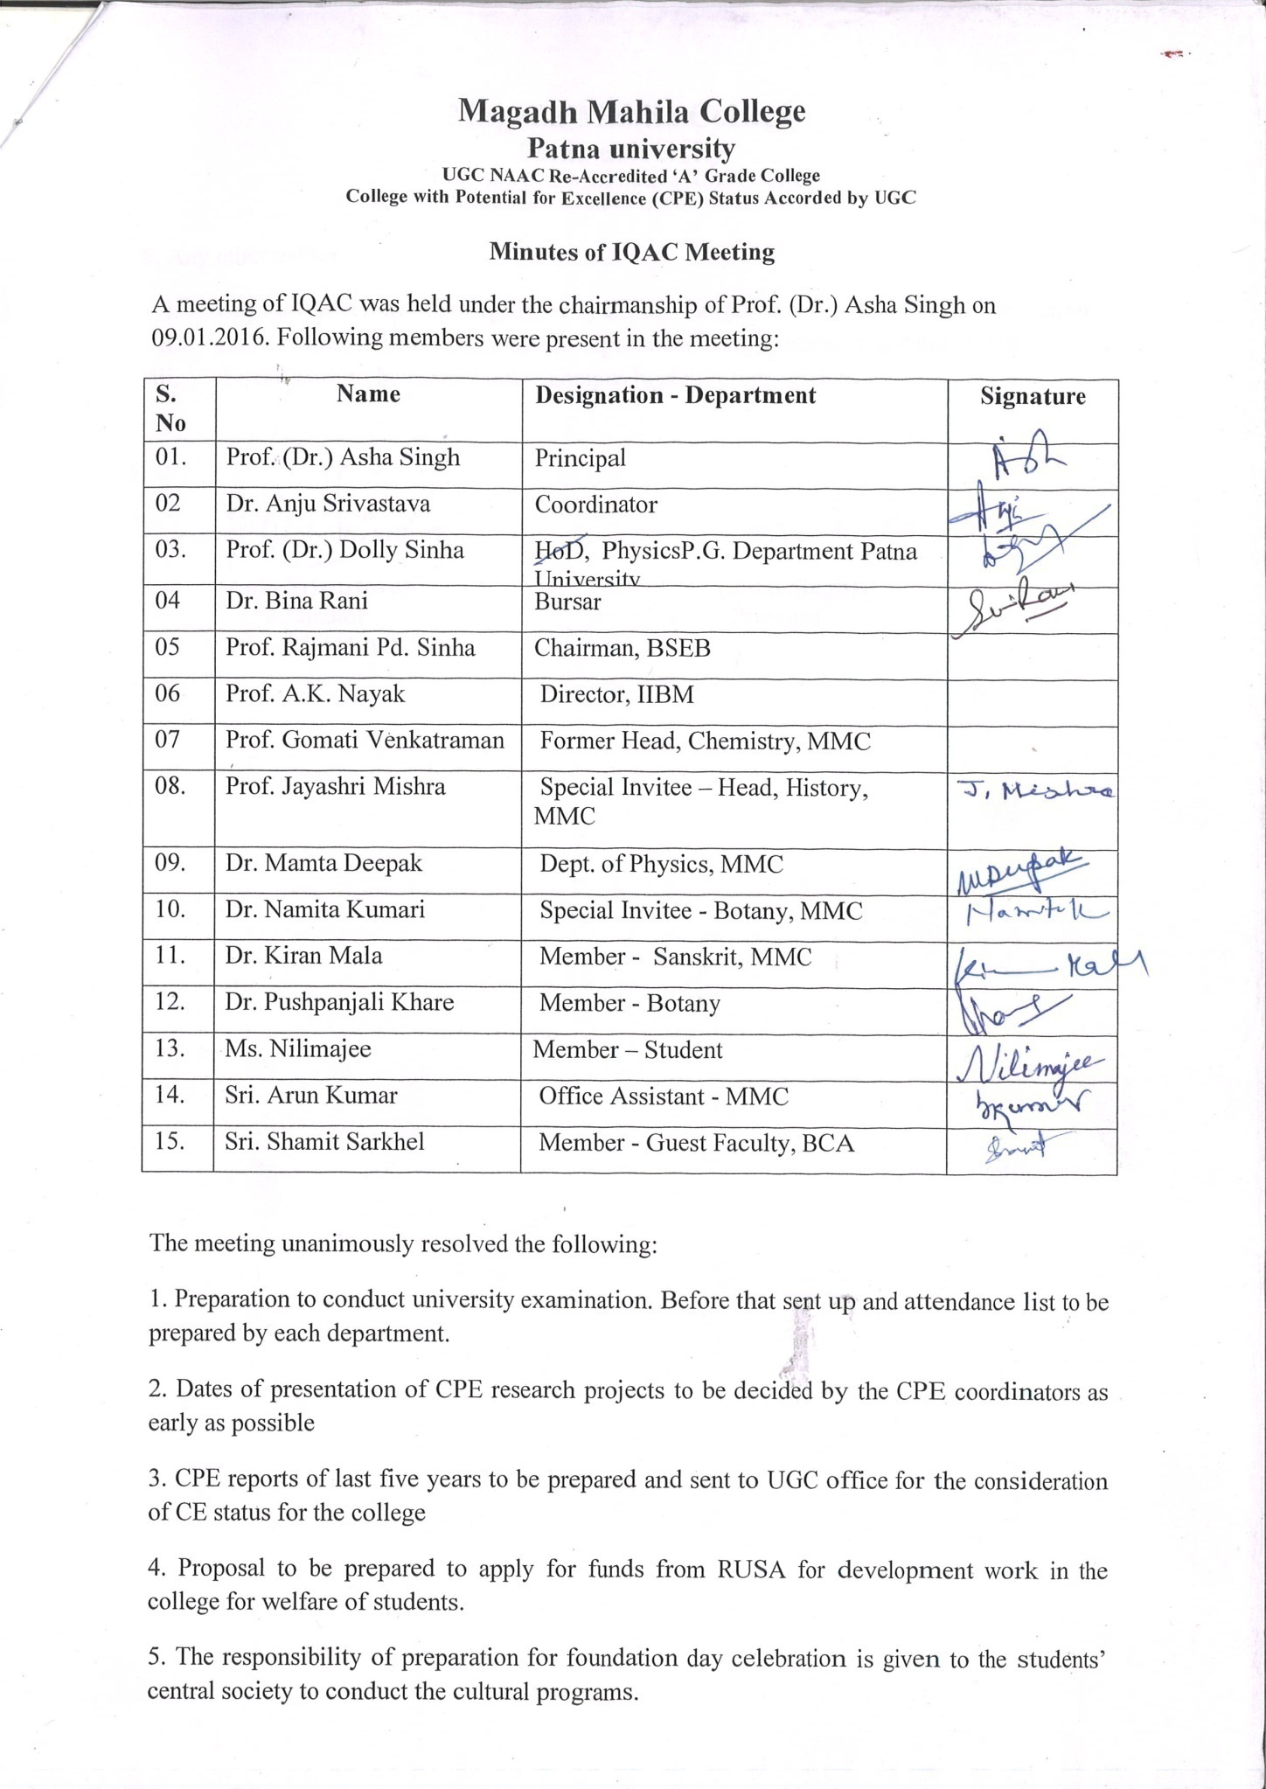

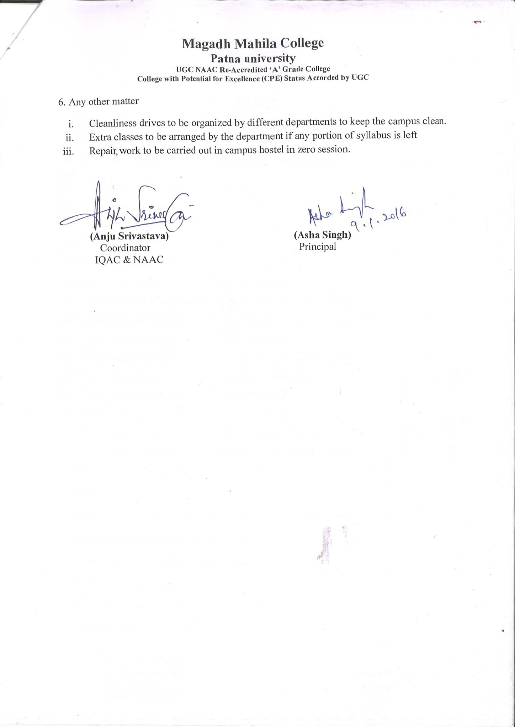

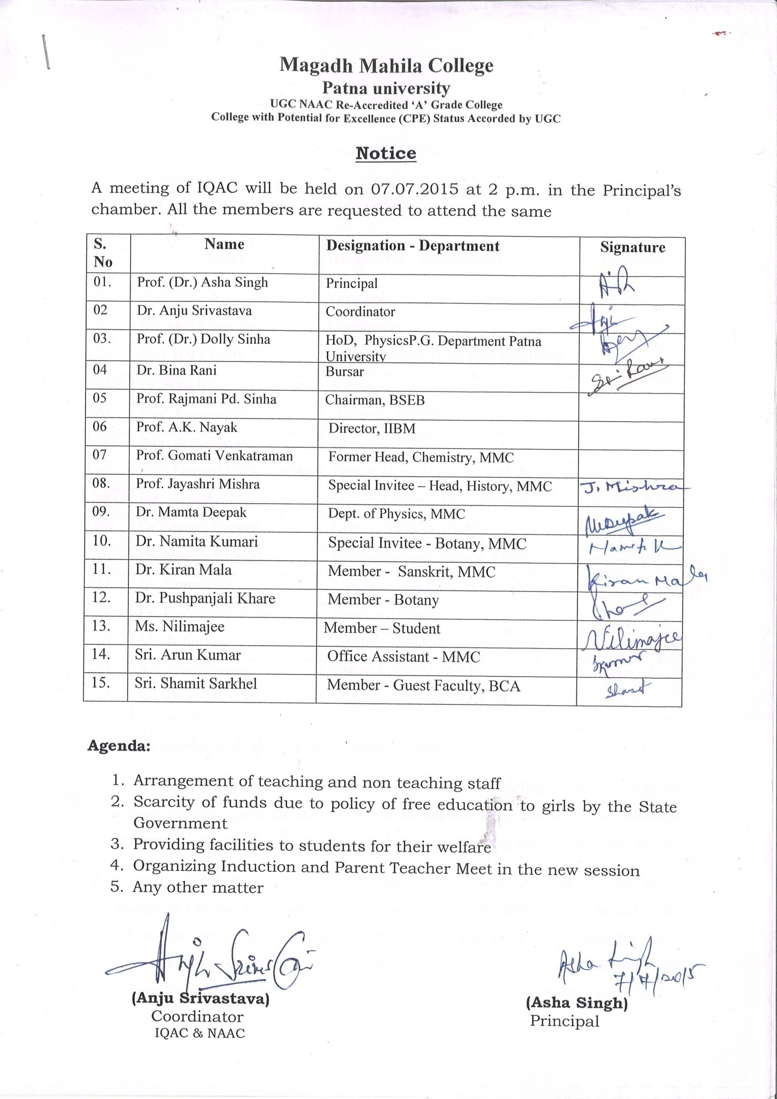

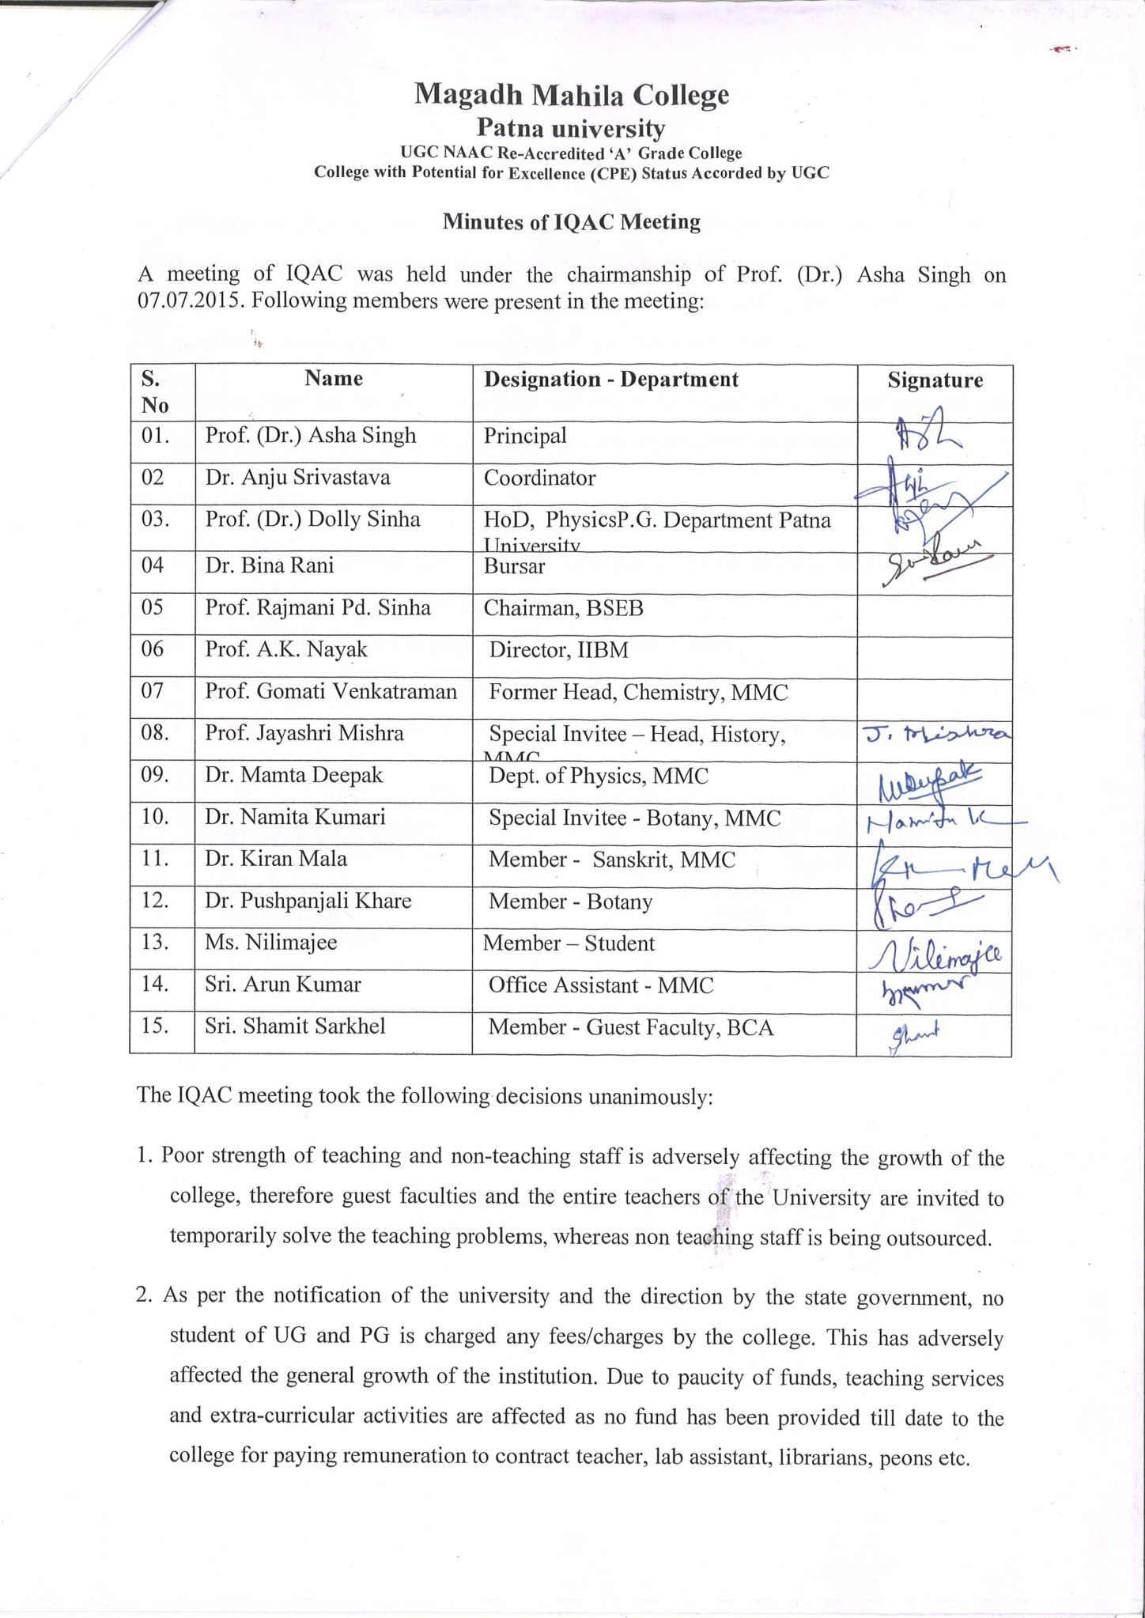

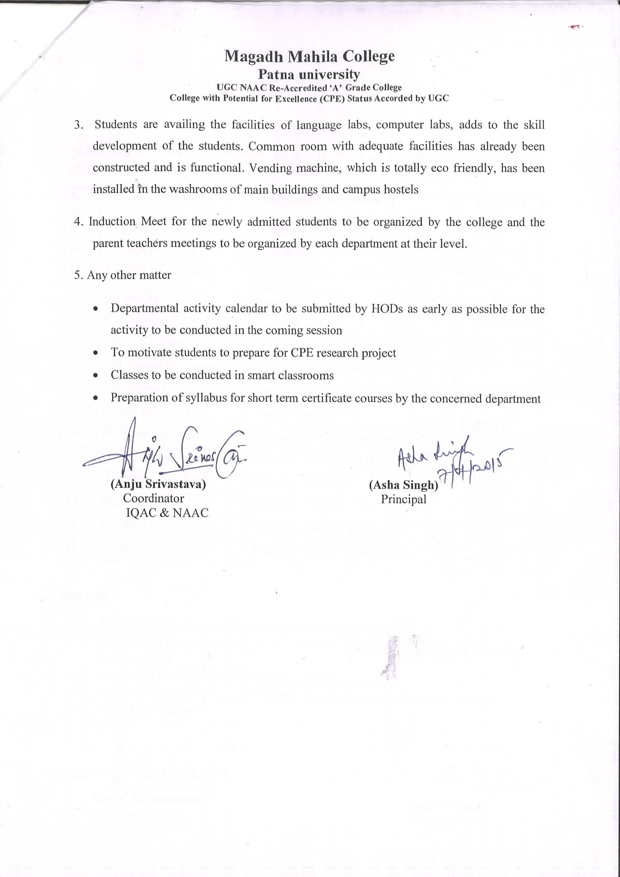

Action Taken 2015-16

- Retired teachers, guest faculty were invited for teaching. Non-teaching staff (grade III and IV) were out-sourced against vacant sanctioned post.
- Induction meet for B.A. 1st year students (Arts, Science, Commerce, Vocational and P.G.) was organised to brief them about the rules, discipline, academic, co-curricular and extracurricular activities.
- Proposal was sent to the government for the release of funds to solve the problems of financial crunch in the college.
- Construction of washroom, classrooms at the 2nd floor, water coolers, sanitary wending machines were installed in the college and hostel washrooms under students welfare programme.
- In light of the coming university examinations, examination committee was constituted which ensured smooth conduct of examinations.
- Various activities under CPE research projects ( 2015-16): preparation of projects, presentation through PPT, preparation of articles for in house journals were carried out by the students (UG and PG) of faculty of Arts, Science, Social Sciences, Humanities, Vocational Courses (Commerce, BBA, BCA). Which were evaluated and reviewed by the external panel of judges. Lastly the whole exercise was reviewed by the coordinators of different faculty and Principal of the college.
- Renovation of classrooms, washrooms, lobby, upgradation of audio video system in central stage, was carried out by RUSA fund.
- Students’ Central Society with the help of faculty members, staff and students prepared for the college foundation day. Series of programmes were planned and organised by them.

